Francisco Barboza crowned 2001 Mexican National Champion
Sideboard Staff
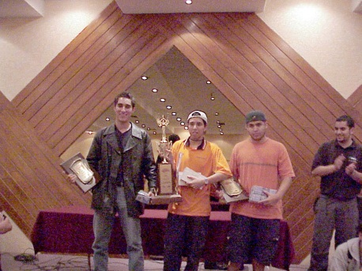
The Mexican National Team
The field Francisco Barboza faced included the 2000 Latin America Continental Champion, Gustavo Chapela, several previous Mexican National Champions, and the winner of Grand Prix - Buenos Aires, Hugo Araiza. The top 8 included a Magic Invitational 2000 participant and perhaps the best-known Mexican player internationally, Gerardo Godinez. But Francisco Barboza persevered, and took home the coveted title of 2001 Mexican National Champion, along with a prize purse of $1700 USD.
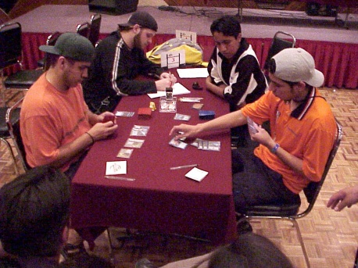
In the finals, Fracisco Barboza faces Carlos Medina
Barboza has done well in tournaments before; he won Mexico City's Pro Tour - Los Angeles 2000 Qualifier tournament and its 2001 Grand Prix - Rio de Janeiro Trial. He also came in top 8 at the 2000 Latin America Continental Championship in Santiago, Chile. Winning the Mexican National Championship puts him on his first step to even greater accomplishments, giving him a spot on the Mexican National Team at Worlds and an invitation to the 2001 Latin America Continental Championship in Buenos Aires, Argentina.
Rounding out the Mexican National Team are Carlos Medina, a resident of Mexico City who took home $1000 USD with his second-place finish, and Messaoud Bouchaib, a Top 8 finisher at Grand Prix - Helsinki who adds $800 USD and the third National Team slot to his list of prizes.
Francisco Barboza
2001 Mexican National Champion
Main Deck |  | Sideboard
20 Island  4 Rishadan Port  4 Rishadan Airship  4 Spiketail Hatchling  4 Troublesome Spirit | 4 Chimeric Idol  4 Brainstorm  3 Daze  4 Foil  3 Rising Waters  4 Thwart  2 Wash Out | 4 Glacial Wall  4 Submerge  2 Wash Out  1 Rising Waters  4 Withdraw

Carlos Medina
2001 Mexican Nationals Finalist
Main Deck |  | Sideboard
12 Island  4 Salt Marsh  2 Swamp  4 Underground River  1 Air Elemental  3 Nether Spirit | 4 Accumulated Knowledge  4 Counterspell  1 Cremate  1 Dominate  3 Fact or Fiction  3 Foil  1 Massacre  4 Opt  2 Power Sink  2 Probe  3 Recoil  1 Tsabo's Decree  1 Tsabo's Web  4 Undermine | 4 Chill  1 Cremate  3 Millstone  2 Misdirection  2 Perish  1 Rebel Informer  2 Tsabo's Decree

Messaoud Bouchaib
2001 Mexican Nationals Third Place
Main Deck |  | Sideboard
4 Crystal Vein  4 Dwarven Ruins  4 Ebon Stronghold  4 Geothermal Crevice  4 Peat Bog  4 Sandstone Needle  4 Sulfur Vent  3 Nether Spirit | 4 Chimeric Idol  3 Ghitu Fire  3 Jokulhaups  4 Obliterate  1 Scorching Lava  4 Seal of Fire  3 Tsabo's Web  3 Urza's Rage  4 Vampiric Tutor | 4 Addle  4 Terminate  2 Cave In  1 Scorching Lava  4 Dread of Night

Jorge Gonzalez Padilla
2001 Mexican Nationals Fourth Place
Main Deck |  | Sideboard
12 Island  4 Salt Marsh  4 Swamp  3 Underground River  1 Air Elemental  3 Nether Spirit | 4 Accumulated Knowledge  4 Counterspell  3 Daze  3 Fact or Fiction  2 Foil  3 Recoil  4 Spite/Malice  3 Terror  2 Tsabo's Decree  1 Tsabo's Web  4 Undermine  1 Vampiric Tutor | 1 Bribery  2 Chill  2 Gainsay  3 Millstone  2 Misdirection  2 Teferi's Response  1 Terror  2 Vendetta

Gerardo Godinez
2001 Mexican Nationals Fifth Place
Main Deck |  | Sideboard
14 Island  3 Swamp  3 Underground River  3 Nether Spirit | 4 Accumulated Knowledge  2 Bribery  4 Counterspell  2 Daze  1 Exclude  3 Fact or Fiction  4 Recoil  2 Spite/Malice  2 Terror  2 Thwart  2 Tsabo's Decree  3 Tsabo's Web  4 Undermine | 2 Perish  3 Lobotomy  3 Millstone  1 Tsabo's Decree  2 Vendetta  1 Terror  3 Gainsay

Julio Cesar Ayala
2001 Mexican Nationals Sixth Place
Main Deck |  | Sideboard
4 Adarkar Wastes  4 Coastal Tower  9 Islands  7 Plains  2 Defiant Falcon  2 Defiant Vanguard  1 Jhovall Queen  2 Lin-Sivvi, Defiant Hero  4 Ramosian Sergeant  2 Ramosian Sky Marshal | 3 Absorb  4 Brainstorm  4 Counterspell  1 Disenchant  2 Dismantling Blow  2 Tsabo's Web  2 Parallax Wave  2 Power Sink  1 Rout  2 Wrath of God | 2 Blinding Angel  2 Circle of Protection: Blue  2 Disenchant  3 Gainsay  3 Last Breath  2 Millstone  1 Rebel Informer

Fernando Dominguez
2001 Mexican Nationals Seventh Place
Main Deck |  | Sideboard
21 Island  1 Air Elemental  4 Rishadan Airship  4 Spiketail Hatchling  4 Troublesome Spirit | 4 Chimeric Idol  4 Gush  2 Sky Diamond  4 Foil  4 Opt  4 Thwart  4 Wash Out | 2 Daze  3 Glacial Wall  3 Rising Waters  4 Submerge  3 Withdraw

Yosef Abadi
2001 Mexican Nationals Eighth Place
Main Deck |  | Sideboard
4 Adarkar Wastes  4 Coastal Tower  10 Islands  7 Plains  4 Blinding Angel  2 Voice of All | 4 Absorb  4 Accumulated Knowledge  4 Blinding Angel  4 Counterspell  3 Dismantling Blow  4 Fact or Fiction  3 Power Sink  1 Rout  2 Tsabo's Web  4 Wrath of God | 3 Millstone  3 Story Circle  3 Misdirection  2 Disenchant  2 Voice of All  1 Tsabo's Web  1 Abduct

